Lemmi

Software Development Plan

Version 2.2

Revision History

| **Date** | **Version** | **Description** | **Author** |
| --- | --- | --- | --- |
| 22/10/2021 | 1.0 | Sections 1, 2, 3, 4.1, 4.3.1, 4.3.2 in Project plan document. | Lemmi |
| 27/10/2021 | 1.1 | Update section 2, 3, 4.2 | Lemmi |
| 30/10/2021 | 1.2 | Review project plan in Sprint 1 | Lemmi |
| 08/11/2021 | 2.0 | Update Configuration Management | Khoa Ta Ngoc Minh |
| 09/11/2021 | 2.1 | Redraw Organization Structure | Tien Nguyen Van |
| 13/11/2021 | 2.2 | Complete Risk Management | Tien Nguyen Van  Van Mai Thi Cam |

Table of Contents

**1.** **Introduction 4**

**2.** **Project Overview 4**

*2.1* *Project Purpose, Scope, and Objectives 4*

*2.2* *Assumptions and Constraints 4*

*2.3* *Project Deliverables 4*

**3.** **Project Organization 4**

*3.1* *Organizational Structure 4*

*3.2* *Roles and Responsibilities 4*

**4.** **Management Process 4**

*4.1* *Project Estimates 4*

*4.2* *Project Plan 4*

4.2.1 Phase and Iteration Plan 5

4.2.2 Releases 5

4.2.3 Project Schedule 5

4.2.4 Project Resourcing 5

*4.3* *Project Monitoring and Control 5*

4.3.1 Reporting 5

4.3.2 Risk Management 5

4.3.3 Configuration Management 6

Software Development Plan

# 

# Introduction

*In this plan, we will outline the overview and organization of the project and the most important, management process. In detail, in the first section of this plan, the purpose of our project as well as its scope and objectives will be clarified. Moreover, a list of assumptions (such as budget, schedule, and human resources) and project deliverables will also be briefly discussed in this section. Furthermore, project organization including organizational structure of our project team and each team member’s responsibilities as well as roles will be given in the second section. The final section will highlight the management process. Management process will contain three main contents: project estimates, project plan and project monitoring.*

# Project Overview

## Project Purpose, Scope, and Objectives

**2.1.1 Purpose:**

This project creates a website that connects people in Vietnam who are passionate about food. We, the creators of this project, try to help people have delicious food that satisfies their appetites. Also, we want this website to be a place where users exchange their opinion about different dishes as well as their experiences. Lastly, the website will somehow promote restaurants, food vendors.

**2.1.2 Scope:**

The website enables users to share posts, comments, and votes on posts, users can search or review their favorite posts. However, social media features like chatting and friend list will not be available. Therefore, the development in the future is focused on building an e-commerce platform.

**2.1.3 Objectives:**

The website aims to become a small social community where people can share their experiences about restaurants, food vendors and help them find delicious food. Besides, it will have the potential to scale to become an e-commerce website, not a complete social media platform with food ordering/shipping as well as a marketplace for advertisement.

## Assumptions and Constraints*.*

**2.2.1 Assumptions:**

* The website will lack some features of social media like chatting, friend lists.
* Mainly focus on the review aspect.
* Initially operating in Ho Chi Minh City, Vietnam.

**2.2.2 Constraints:**

* All of the development resources are free.
* The project is server-side rendering.
* Key required functionality: login, register, posts, comments.
* Anyone from the team might be involved in different development roles.

## Project Deliverables

| **Deliverables** | **Target delivery date** |
| --- | --- |
| Software Development Plan | 13/11/2021 |
| Vision Document | 13/11/2021 |
| Business Use Cases | 27/11/2021 |
| Glossary | 27/11/2021 |
| Supplementary Specification | 27/11/2021 |
| Software Architecture Document | 11/12/2021 |
| Creative Design Briefs | 04/12/2021 |
| User Interface Prototype | 11/12/2021 |
| Data Model | 04/12/2021 |
| Design Model | 11/12/2021 |
| Database Design | 11/12/2021 |
| Implement | 20/12/2021 |
| Build | 25/12/2021 |
| Test Package | 18/12/2021 |
| Change Requests | 20/12/2021 |
| Test Summary | 25/12/2021 |
| Release Notes | 31/12/2021 |

# Project Organization

## Organizational Structure

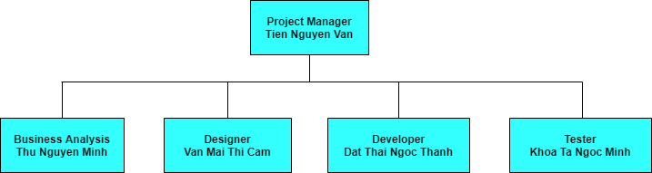

## Roles and Responsibilities

| **Person** | **Role** | **Description** |
| --- | --- | --- |
| Tien Nguyen Van | Project Manager | Allocate resources, define tasks for each team member, and keep the project team focused on the right goal. |
| Thu Nguyen Minh | Business Analyst | Lead and coordinate business use-case modeling, by outlining and delimiting the organization being modeled. |
| Van Mai Thi Cam | Designer | Design friendly user interface and figure out user experiment |
| Dat Thai Ngoc Thanh | Developer | Lead developer team in building the project |
| Khoa Ta Ngoc Minh | Tester | Responsible for executing testing, evaluating of test and writing test summary |

# Management Process

## Project Estimates

## Project Plan

### **Phase and Iteration Plan.**

| **Phase name** | **Start** | **End** | **Overall Objectives** |
| --- | --- | --- | --- |
| Inception | 16/10/2021 | 30/10/2021 | Determine plan and vision document of our project throughout the process of developing users' requirements. |
| Elaboration | 30/10/2021 | 27/11/2021 | Analyze the requirements and determine the architectural prototype by verifying the primary components to test the feasibility and performance for the early one. |
| Construction | 28/11/2021 | 25/12/2021 | Implement software with all key features in the highest possible product quality. We will create and evaluate the first version then will enhance the new one. |

| Phase Name | No. Of Iteration | Achievement |
| --- | --- | --- |
| Inception | 1 | - An initial version of the project plan.  - An initial version of the vision document. |
| Elaboration | 2 | - Updated version of the project plan: fix issues, make clearer, detail the schedule.  - More detailed vision document: detailed product functional and non-functional requirements, alternatives and competitors, user environments.  - Use-case model: in forms of use-case diagrams.  - Use-case specification: detail each use-case in the use-case diagrams. |
| 3 | - Revised the use-case model and use-case specifications: more details and use-cases.  - An initial software architecture document: key components and the organization of these components to form the architecture, languages are used.  - Class diagrams: for each of the key components. |
| Construction | 4 | - Revised software architecture document: more information, deployment diagram(s) using UML and description, structures for folders that store code and supporting files.  - UI prototype: a sketch of the user interface for the system and each screen’s description. |
| 5 | - 1st release with key features.  - Test plan and test cases: 3 features for testing and at least 5 test cases for each feature, a test report listing all defects found.  - Automated testing: each team member performs automated tests for at least one feature with at least two scenarios. |

### **Releases**

At this point in time, 2 software releases are planned:

* 1 beta version on 15/12/2021
* 1 official release on 31/12/2021

### **Project Schedule**

Link: [ProjectSchedule.png](https://drive.google.com/file/d/1f3tPMp-ZyjEXyHlzu1aQdXXS24XCZHV0/view?usp=sharing)

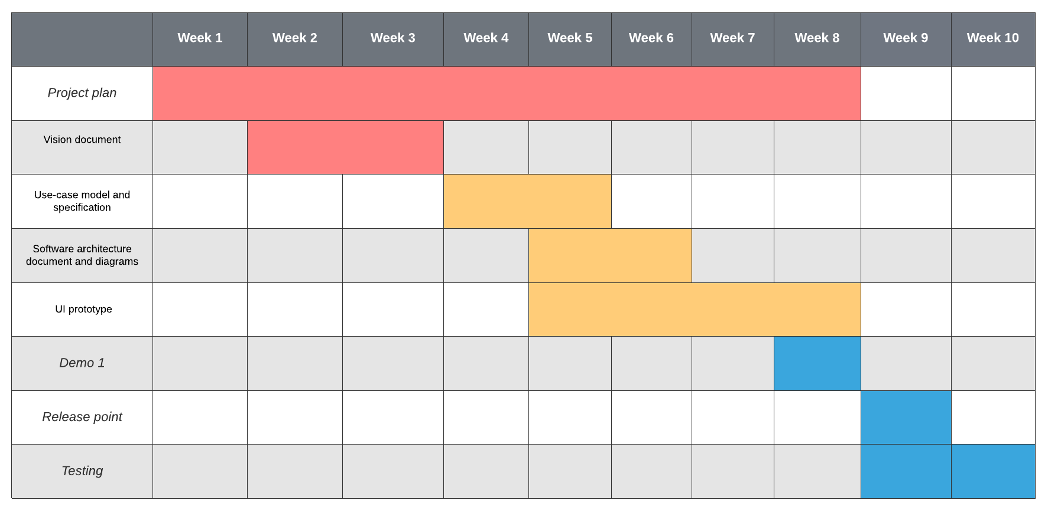

## Project Monitoring and Control

### **Reporting**

The Report for weekly is captured in the Weekly Report document. Each week we will review achievements since last week, set the next week's goals, and discuss issues and impacts we have in the last week.

### **Risk Management**

| **Risk ID** | **Risk Description** | **Probability** | **Impact** | **Priority** | **Mitigation Strategy or Contingency Plan** |
| --- | --- | --- | --- | --- | --- |
| 1 | Schedule slippage. Someone does not have enough time to complete tasks. | 50% | The project can not be completed successfully at the deadline.  Affect after tasks. | 1 | - Extend the deadline to the next scum in the same sprint.  - Move to the next sprint if schedule permits.  - Break tasks and add more teammates to help complete tasks. |
| 2 | Changes in requirements. | 25% | Affect on tasks dependent on requirements. | 2 | - Make a meeting to backtrack tasks or artifacts affected by changing old requirements to new requirements.  - For old tasks that needed to be changed, assigning to teammates who responded for.  - Planning schedule again from the changing point. |
| 3 | Capacity and Capability. Inability to deliver a solution that meets requirements. | 5% | The system does not function well. | 3 | - Review about software architecture. |

### **Configuration Management**

* Google drive: storing and sharing documents and files.
* Github: storing and sharing code and submission files to build and edit our Web application.
* Slack: messaging and connecting teammates to the information they need.
* Google meeting: video meetings, audio, meeting recordings, and live chat.
* Trello: Organizing and planning projects into boards. Tell what's being worked on, who's working on what, and where something is in a process
* Draw.io : create UML online, as an ER diagram tool, to design database schema, to build BPMN online, as a circuit diagram maker
* Figma: is a web**-**based graphics editing and user interface design app. You can use it to do all kinds of graphic design work from wireframing websites, designing mobile app interfaces, prototyping designs, crafting social media posts, and everything in between